

V1.0

Sentiment Analysis PDD

Process Design Document History FOR TESTING

|  |  |  |  |  |  |  |  |
| --- | --- | --- | --- | --- | --- | --- | --- |
| **Date** | **Version No** | **Version Role** | **Name** | **Reviewer** | **Organization** | **Function** | **Comments** |
| 2/7/2021 | 0.0 | Draft | Rajashri | Ruchi | HSI | Sentiment Analysis | Creation |
| 6/7/2021 | 0.1 |  | Ruchi | Rajashri | HIS | Sentiment Analysis | Incorporated review comments |
| 7/7/2021 | 0.2 |  | Rajashri | Ruchi | HIS | Added the config file details |  |
| 18/7/2021 | 0.3 |  | Rajashri |  |  | Added Screenshots |  |
| 19/07/2021 | 1.0 |  | Ruchi |  |  | Baselined |  |

# Contents

1 Contents 2

1 Introduction 3

2 AS IS Process Description 3

2.1 Process Overview 3

2.1.1 In scope for RPA 4

1) Reading the mails for language analysis (English only). 4

2.1.2 Out Of scope for RPA 4

2.2 AS IS Process Description 4

2.3 Detailed Process Steps 5

2.4 Exception Handling 6

The types of exceptions identifiable in the automation process can be classified according to the table below. 6

2.5 Error mapping and Handling 6

2.5.1 In-scope Application details 7

2.6 Reporting 8

3 Development details 8

3.1 Prerequisites for development 8

3.2 Password policies 9

3.3 Credentials and asset management 9

4 Document Approval Flow 9

5 Appendix 9

5.1 UiPath automated process details 9

# Introduction

* 1. Purpose of the document

This Process design document describes the business process chosen for analysing the sentiments of the customers using the AI Centre of UIPath RPA technology.

It describes the sequence of steps performed as part of the process, as well as the conditions and requirements prior to its automation. This design document serves as a base document for developers to collect the details required for the robotic automation of the same business processes.

* 1. Objectives

The customer shares the sentiments regarding a product via email. Currently the emails are analysed manually to identify the next steps for improvement. However, sifting through the emails takes a long time and hence there is a need to automate this analysis using language skills.

AI Centre’s ability to analyse the language using machine learning skills, and identify the sentiment of the customer will be used in this project to improve the speed at which emails are analysed and identified.

The functional objective of this automation is to:

* Extract the email content
* Perform Sentiment Analysis for different mails (Document Understanding – AI Fabric)
* Save the details of sentiments in excel sheet
* Create Dashboard

# AS IS Process Description

## Process Overview

General information about the process selected for RPA implementation, prior to its automation:

|  |  |
| --- | --- |
| AlS IS process details | |
| Process full name | Sentiment Analysis |
| Process short description (operation, activity, outcome) | Analyze the emails for the sentiments of the customer, store the same in an excel sheet and create a dashboard for the same |
| Role required for performing the process | User |
| Process schedule | Daily |
| # of item processes / day | 20-25 emails |
| Average handling time per item | 2 min/email |
| Peak period (s) | No peak period |
| # of FTEs supporting this activity | 1 |
| Level of exception rate | No exception |
| Input data | Emails from the customer |
| Output data | Sentiment Analysis saved in excel format, and dashboard. |

### In scope for RPA

The activities in this process that are in the scope for RPA, are listed below:

# Reading the mails for language analysis (English only).

1. Identifying the sentiments of the customer, and logging them
2. Creating a dashboard

### Out Of scope for RPA

The activities and exceptions in this process that are out of the scope for RPA, are listed below:

1. Generating emails (For our project we will consider emails are already sent to a particular id)

## AS IS Process Description

## Detailed Process Steps

The complete set of steps in the process, including keystrokes and clicks, are to be defined with screenshots. If there are any data restrictions, mask the sensitive information, such as email password, etc).

|  |  |  |  |  |
| --- | --- | --- | --- | --- |
| **#** | **Step Action Description** | **Screenshot** | **Expected Result** | **Remarks** |
| 1 | Load Configuration Settings |  | The AI center is connected and Config file is loaded | Exception: Config file not available |
| 2 | Login to Mail Server |  | The mail server is accessible, and the mails are retrieved | Exception: Mail Server not Available |
| 3 | Retrieve Email for Sentiment Analysis |  | Each mail is downloaded and loaded into Mailing list | Exception: No Mails are Available |
| 4 | For each Mail Apply Machine Skill |  | Get the confidence level, and the sentiment | Review comments are empty or non-processible by JSON |
| 5 | Write Body of email i.e. Customer Feedback, Date of feedback provided, sentiment and confidence back to excel sheet |  |  |  |
| 6 | Display Dashboard |  |  |  |

## Exception Handling

## The types of exceptions identifiable in the automation process can be classified according to the table below.

|  |  |  |
| --- | --- | --- |
| **Area** | **Known** | **Unknown** |
| BusinessException | Previously encountered situation. A possible scenario is defined, and clear actions and workarounds are  provided for each case. | A situation never encountered before. It can be caused by external factors. |

Based on the above criteria, the table below should reflect all the known exceptions identified throughout the process and map the expected action the robot needs to take in each case.

Insert as many rows as required in the table, to capture all exceptions in a comprehensive list.

|  |  |  |  |  |
| --- | --- | --- | --- | --- |
| **#** | **Exception Name** | **Step Where Exception is Encountered** | **Parameters** | **Action To be token** |
| 1 | No Mails are available | 3 | No review mails are available | Log the message and exit |

For any other exception, log the exception and save the screenshot in exception folder.

## Error mapping and Handling

A comprehensive list of all the errors, warnings, or notifications should be consolidated here with the description and action to be taken by the Robot in each case.

The errors identified in the automation process can be classified according to the table below.

|  |  |  |
| --- | --- | --- |
| **Areas** | **Known** | **Unknown** |
| Technology | Previously encountered situation – action plan or work around available | A situation never encountered before, or may happened independent of applications used in the process |

Based on the above criteria, the table below should reflect all the identifiable errors in the process, and map the expected action of the Robot in each case.

|  |  |  |  |  |
| --- | --- | --- | --- | --- |
| **#** | **Exception Name** | **Step Where Exception is Encountered** | **Parameters** | **Action To be token** |
| 1 | IOException | 1 | While Loading the config file, the file is not available | Log the exception and terminate |
| 2 | Email server not accessible | 2 | While connecting to the email server , server not accessible due to incorrect parameters | Log the exception and terminate |
| 3 | Incorrect Userid/Password | 2 | While connecting to server, the server throws an invalid user Id and password | Log the exception and terminate |
| 4 | JSON parsing error | 5 | Review comments are empty or non-processible by JSON | Log the exception and continue for the next mail |
| 5 | Excel cannot be opened |  | Excel is already open, and cannot be opened | Retry by killing the process or asking the user to close the excel |

## In-scope Application details

The table below lists all the applications that are used as part of the automated process.

|  |  |  |  |  |  |  |
| --- | --- | --- | --- | --- | --- | --- |
| **#** | **Application Name and Version** | **System Language** | **Login Module** | **Interface** | **Environment/Access Mthod** | **Comments** |
|  |  |  |  |  |  |  |
|  |  |  |  |  |  |  |

## Reporting

|  |  |  |  |
| --- | --- | --- | --- |
| Report # | Report Type | Update Frequency | Details |
| 1 | Dashboard | Weekly | The weekly review comments are analyzed for sentiments and the dashboard is created for the same. It will be updated in “SentimentAnalysis.xlsx” |
|  |  |  |  |

# Development details

## Prerequisites for development

• Development or testing environment are to be provided for development purposes.

• The provided development and testing environments are exact replicas of the production environment.

• Dedicated system and application access are given to developers with the adequate

permissions.

Following entries are made for configuration

|  |  |  |  |  |
| --- | --- | --- | --- | --- |
| **File** | **Sheet** | **Name** | **Value** | **Descriotion** |
| Config.xlsx | Settings | Gmail_Credential | Gmail_Credential2 | The email id pwd registered for feedback on the orchestrator |
| Config.xlsx | Settings | output_file | “SentimentAnalysis.xlsx” | The file created with results and dashboard |
| Config.xlsx | Constants | PRODUCTCOUNT | 3 |  |
| Config.xlsx | Constants | |  | | --- | | PRODUCT1 | |  | |  | | UIPath |  |
| Config.xlsx | Constants | PRODUCT2 | Automation Anywhere |  |
| Config.xlsx | Constants | PRODUCT3 | Blue Prism |  |

## Password policies

Users manage their own passwords. There are no special policies in place.

## Credentials and asset management

Login details (user IDs and passwords) should be stored under Windows Credential Manager or

UiPath Orchestrator Assets.

# Document Approval Flow

|  |  |  |  |  |  |
| --- | --- | --- | --- | --- | --- |
| **Version** | **Flow** | **Role** | **Name** | **Organization**  **(Dept.)** | **Signature**  **and Date:** |
| 0.0 | Draft Document | Developer | Rajashri | HIS | 6/7/2021 |
| 0.1 | Incorporated comments | Developer | Ruchi | HIS | 7/7/21 |

# Appendix

## UiPath automated process details

**Note: this step is to be filled in after automation process is complete**

**Automation overview**: 7FTE to develop,3 FTE to test, 2FTE for POC, 2 FTE for learning new skills like macros etc.

**Robots type**: Unattended

**Level of human intervention required**: None

**Use of Orchestrator**: AI Centre

**Exceptions recorded in automation process**: System Exception, Business Exception

**Errors identified in the automation process**: None

**Challenges identified in the automation process**: Macros, load time for emails is high

**Lessons Learned**:

Macros were generated to create a dashboard, the loading and analysing of emails was high. So the input to the system was internally converted to excel sheets to speed up the process.

➢ Process Assumption – All mails sent to a particular mail id contain the feedback, and are in English language

➢ Input data assumption – Feedback received from customers are contained in a particular mail id. No other mails are available in this mail id. The subject contains the product and the date of mail (Since the data was scraped at a single time)

➢ Number or types of input to be received – 20-25 per day

➢ Skipping the login interface and collecting backend details - NA

➢ Extracting backend data without opening the file - NA

➢ Data conversion / formatting - NA

**Reporting:** The details and format of the logging mechanism available in the workflow have to be specified here, whether it is a local log report or the Orchestrator log).

The format should be specified by the business users.

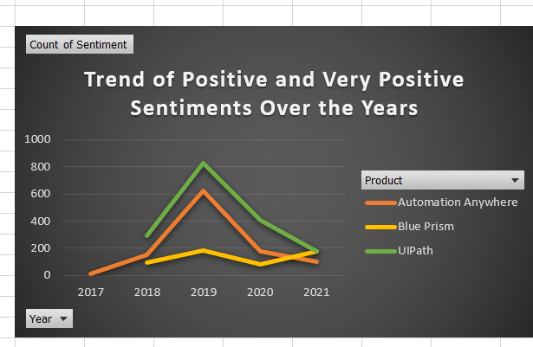

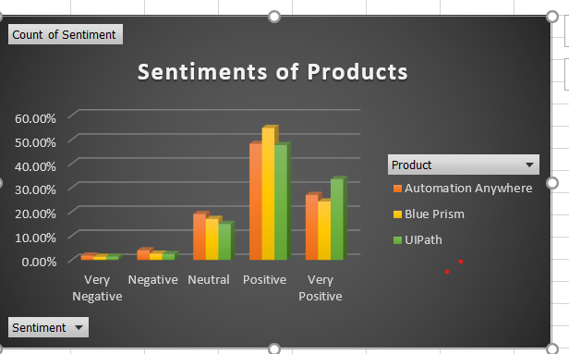

**Workflow and scripts:** A brief overview of each workflow and the sequence in which it is executed should be provided here.

1. Process.xaml –

Calling Procedure – ProcessTransaction of Main.xaml

Logic - Contains the business logic of the project to call appropriate workflows

Invokes - GetMailDetails workflow

WriteToExcel workflow.

1. GetmailDetails.xaml –

Calling Procedure – Process.xaml

Logic - Contains the business logic to read through the mails , and gets the productname, date of mail, feedback. Sends the feedback to PerformSentimentAnalysis.xaml to get the sentiments and confidence level. Wraps the data in a datatable

Invokes - PerformSentimentAnalysis.xaml

1. PerformSentimentAnalysis.xaml

Calling Procedure – GetmailDetails.xaml

Logic - Contains the business logic to analyze the sentiments and confidence level.

Invokes - None

1. WriteToExcel.xaml

Calling Procedure – Process.xaml

Logic - Contains the business logic to read the datatable and create an excel sheet with each sheet pertaining to the product.

Invokes - None

1. CreateDashboard.xaml

Calling Procedure – ProcessTrainsaction of Main.xaml

Logic – If no exception, then create pivot data from the rawdata in excel, and then create a dashboard.

Invokes - Macros

1. CreateDashboardAnalysis.xaml

Calling Procedure – ProcessTrainsaction of Main.xaml

Logic – If no exception, then generate an analysis of the time used when run by a human being and when run by the bot.

Invokes - None